**Synchrony**

**Question:- List<Employee> , display employee whose salary > 40000 ?**

**Ans:-**

**Question 2nd: -What is output of below program?**

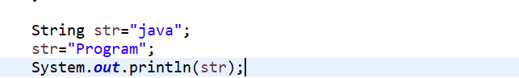

**Ans: - Program**

**Question 3ed: - Stream.of(5,3,1,7,2,9) sort array in reverse Order ?**

**Ans:-**

**Question 4th: - What is completeable future in java 8?**

**Ans:-** 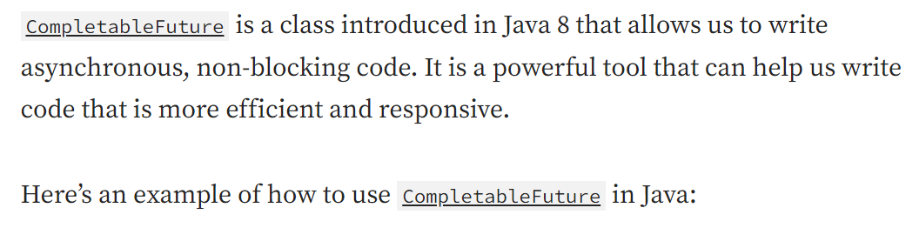

**Question 4th: - What is completeable future in java 8?**

**Ans:-**

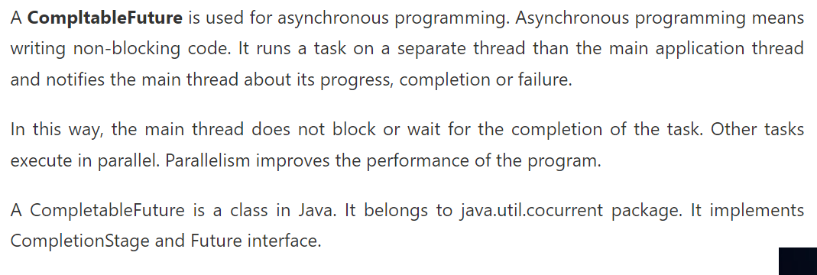

**OR**

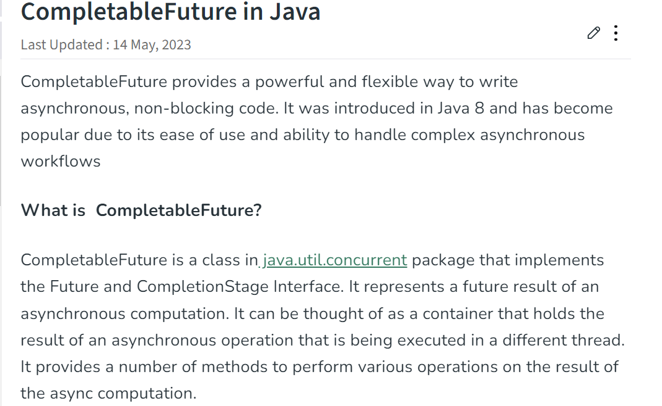

**Question 5th: - Find minimum value in an Interger List in Java 8?**

**Ans:-**

**1)** 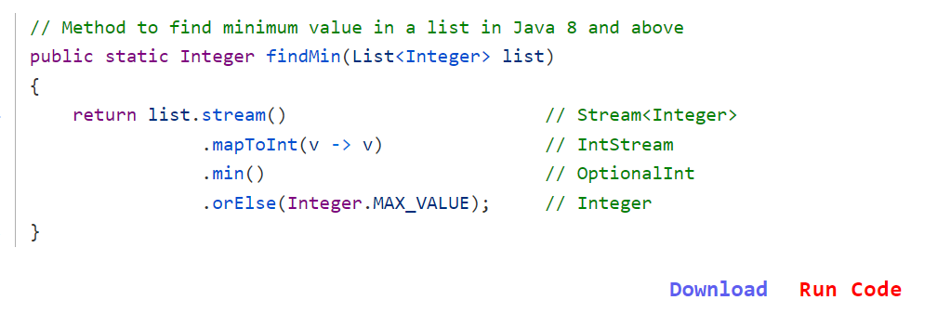

**2)** 

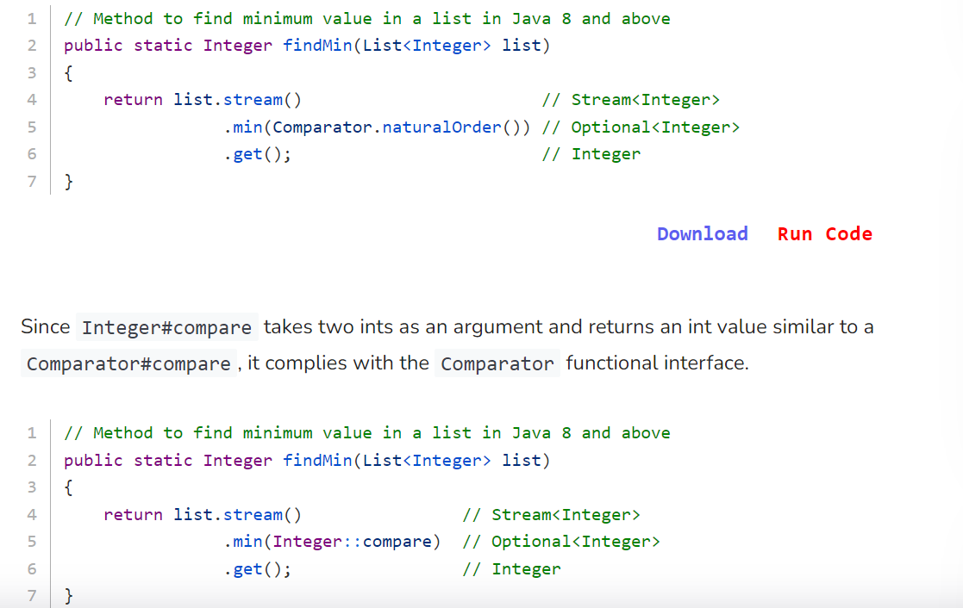

**3)**

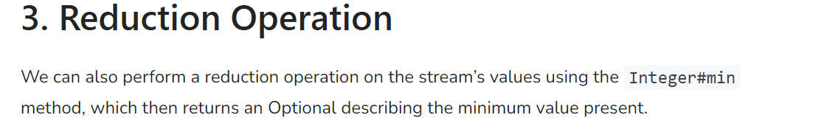

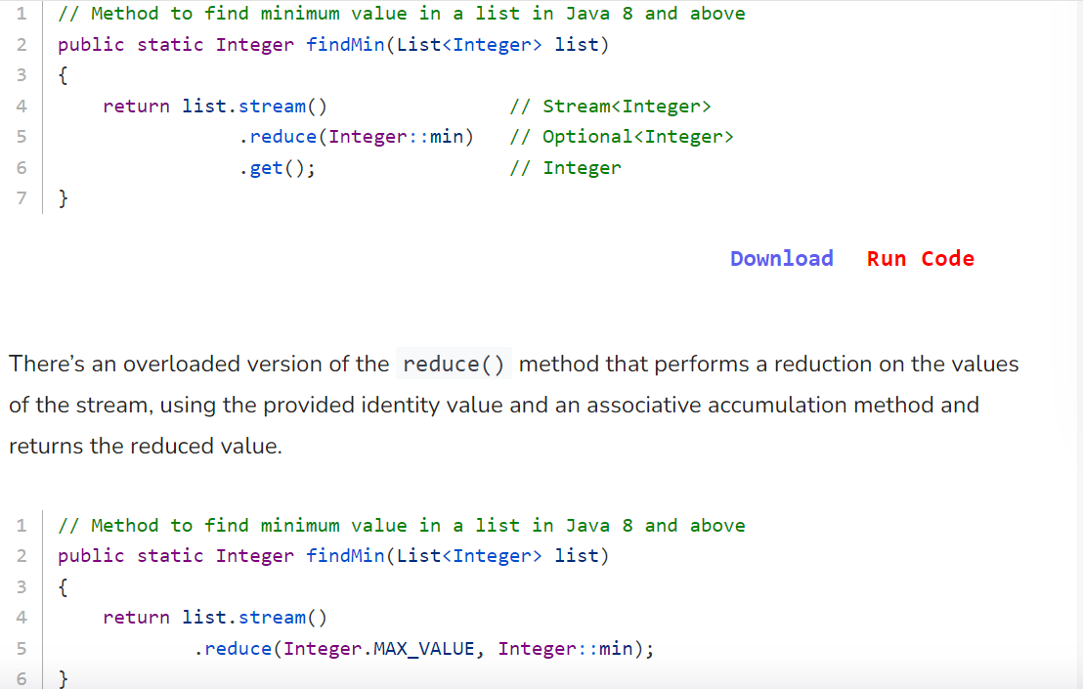

**4)**

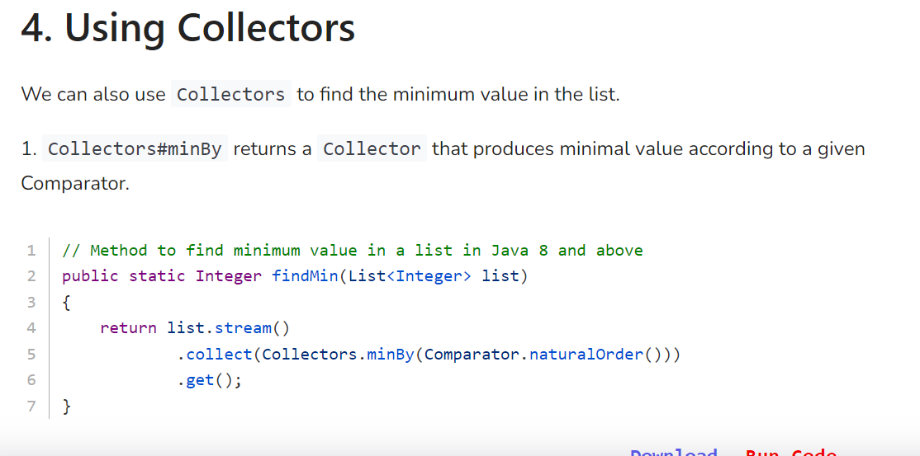

**5)**

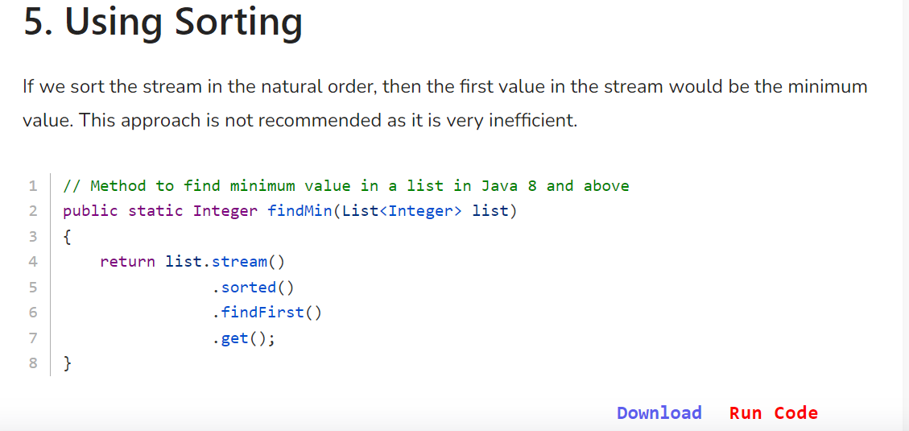

**Question 6th: -**

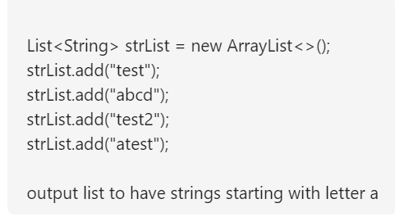

**Ans:-**

